**LEBANESE AMERICAN UNIVERSITY**

**MECHANICAL ENGINEERING DEPARTMENT**

**Kinematics Project Report**

**Charbel Beaini**

**Lynn Aizarani**

**Reynald Maroun Aouad**

**Tarek El Shammas**

**MEE 341 - Kinematics of Machines**

**Instructor: Jacques Abboud**

**Thursday, 27th of April, 2023**

Table of Contents

2. Gravity Battery 3

2.1 What is it exactly ? 3

2.2 Belt mechanism 4

2.3 Kinematics Explanation: 4

2.3.1 The Gears: 4

2.4 The Matlab code: 6

2.5 Solidworks Design: 7

3. Gearbox with a four-bar mechanism 8

3.1 What is a crank rocker ? 8

3.2 Kinematics Explanation: 9

3.2.1 Crank-Rocker mechanism 9

3.2.2 The Gears: 11

3.3 The MATLAB Code of our output 12

3.4 Solidworks Design of gearbox and 4 bar mechanism: 18

4. Proof of concept: 20

# Gravity Battery

## What is it exactly ?

Gravity batteries are an emerging technology that offer several advantages over traditional batteries, such as longer lifespan and potentially lower cost. They also have the potential to be used in large-scale energy storage systems, such as for renewable energy sources like wind and solar power.

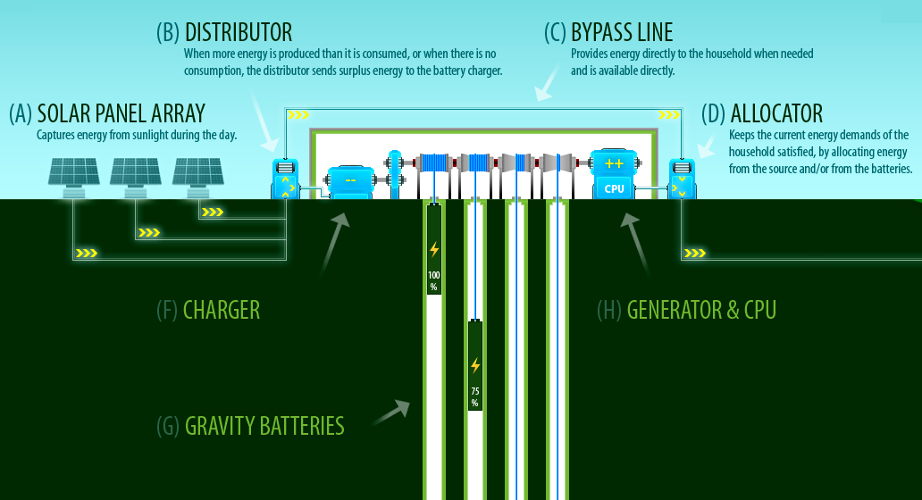They are a type of energy storage device that uses gravity as the energy source. It works by lifting a heavy weight (such as a large mass of concrete or a container of water) to a high altitude using a motor or other energy source. The potential energy stored in the weight can then be converted back into electricity when needed by allowing the weight to descend and using a generator to capture the energy.

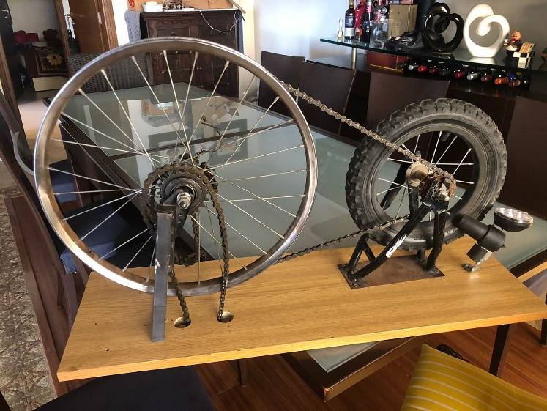

## Belt mechanism

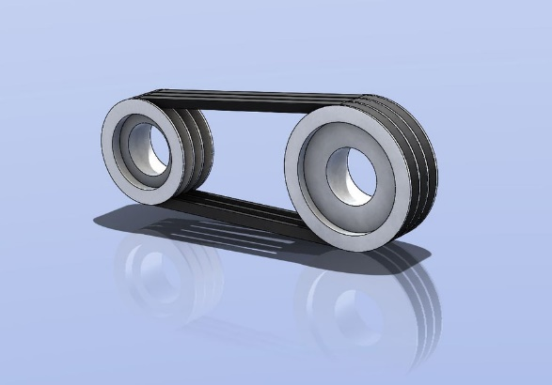In our design, we connected two wheels using a belt. That was done by choosing a 5V belt. We set the distance between the 2 centers such that d2 < C < 3(d1 + d2), in order to prevent fatigue and vibrations as much as possible; with C the center distance and is equal to 146mm, d1 and d2 the diameters of the driving and trailing wheels equal to 10mm and 70mm respectively.

And so, we obtain the following equation:

We obtained the values of w1/w2 to be equal to 7. We then assumed that the belt in the design is efficient and rotates at a speed of 35rpm (which is low but we wanted it to match real life application) . This leaves us with the following equation:

Accordingly, depending on the design and on the slider crank, the speed of the belt can be calculated.

## The Matlab code:

The following pictures are some screenshots of the code:

## Solidworks Design:

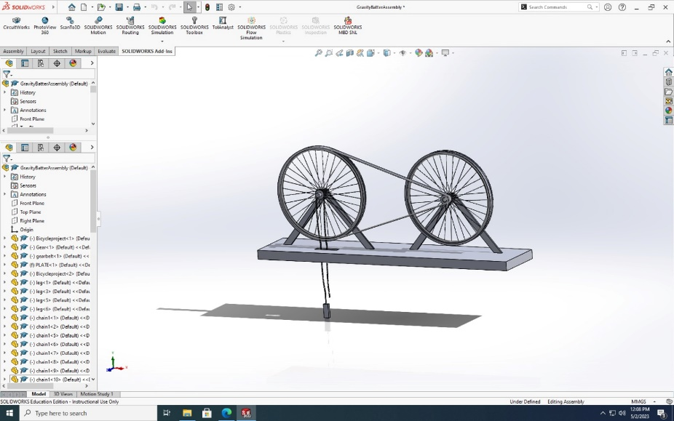

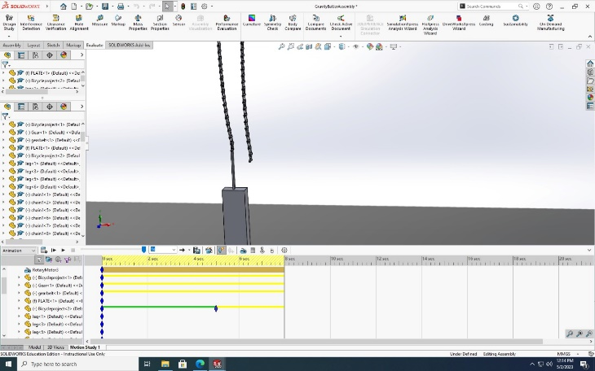

The following is our Solidworks design. We took the appropriate measures to our proof of concept. What we changed was the four-bar crank-rocker mechanism.

# Gearbox with a four-bar mechanism

## What is a crank rocker ?

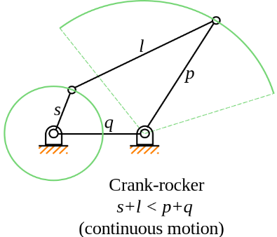A four-bar device known as a crank rocker has a rocker attached to another link, and when the crank is turned, the rocker oscillates back and forth, moving the other links reciprocally. The crank rocker converts the rotary motion into oscillatory motion as a result. In our example, we converted it into the rotating motion of the crank by using the oscillatory motion.

To achieve this kind of mechanism, it is important to check for the type I Grashof condition. S + L < P + Q.

In order to have a crank rocker, the indicated condition must be met, with the shortest link S as the crank and adjacent link as the ground.

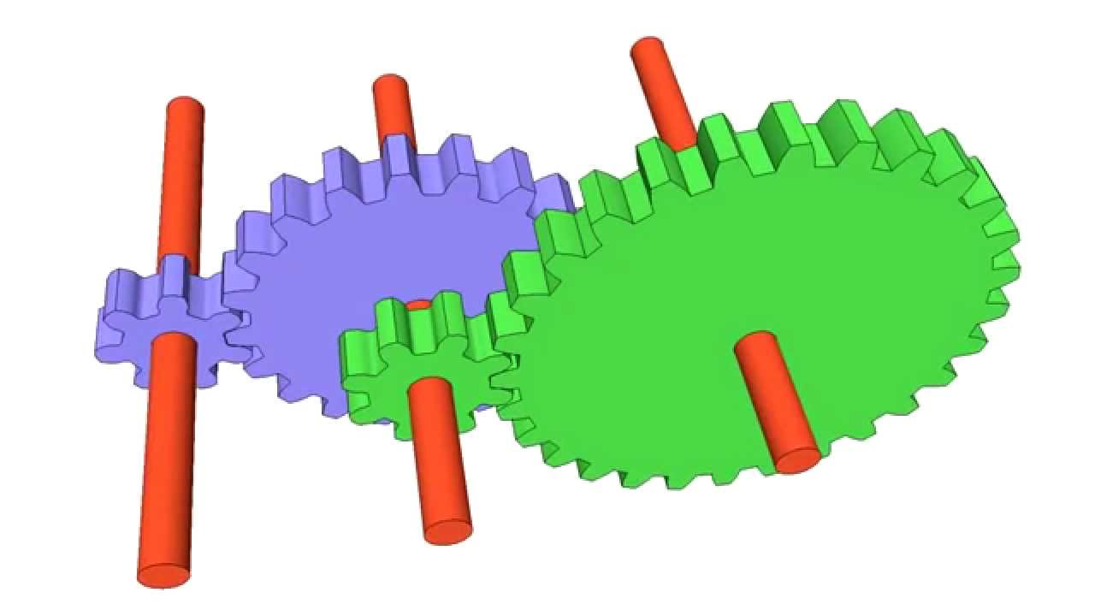What are gears and what are their functions?

There are several different machines and mechanisms that use external gears. Their primary and most important role is to transmit rotational motion and torque between two or more components.

In a gearbox they present a range of gear ratios that adjust the torque and speed provided.

In order to maximize the efficiency of the system, different gear ratios can be accomplished by altering the pitch diameter, size, and number of teeth of a gear.

Other features offered by external gears include decreased backlash, noise cancellation, improved reliability, and so on.

## Kinematics Explanation:

### Crank-Rocker mechanism

The first and foremost step is to design the length of the linkages. We let the user input the desired values as long as they satisfy the Grashof condition in which S + L < P + Q.

On the following drawing, we specified the lengths of each link R2=3cm, R3=7.5cm, R4=4.5cm, and R1=7cm. We also specified the positions of the angles O2, O3, and O4. We rotated the x and y axes so that the x-axis is along link d and the y axis is parallel to link c. The angle between the horizontal and link d downwards is 35 degrees.



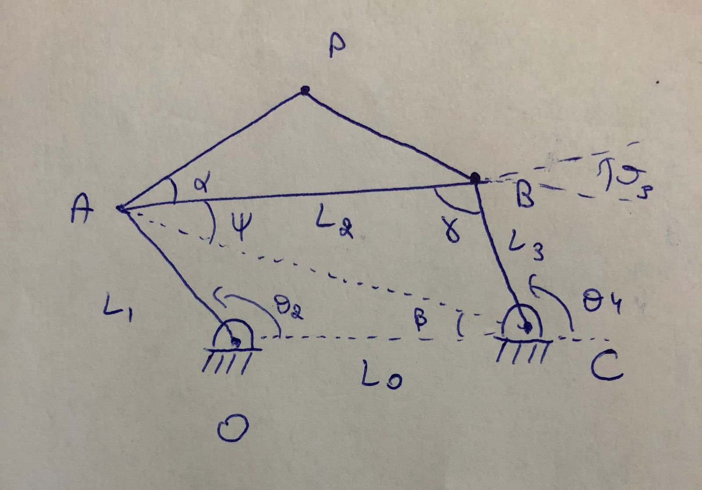

This is the approach seen in class:

Position: (links d and c are perpendicular where O4 = 90 degrees)

The first analysis of positions was done when we considered that links c and d are perpendicular. We obtained the following results:

Real part:

Imaginary part:

In which we need to find O2 and O3.

Isolate O3:

Square both sides:

Add both expressions:

Rearrange equation:

Use the Weierstrass substitution where:

After replacing with our known numbers and solving the above equation, we were able to get the values of O2 and O3

These angles validate the shape of our figure drawn on Matlab when we considered that c and d are perpendicular.

### The Gears:

Based on previous studies regarding gears and their common applications, a diametral pitch is chosen according to its specific application, requirements, needed torque and speed, and so on. A diametral pitch of Pd = 8 is an appropriate diametral pitch for our chainless bike.

We also decided to use a pressure angle of 20 degrees since it is a compromise and a common pressure angle. Indeed, a high-pressure angle of around 25 results in high load handle. However, higher sliding and higher stresses on the gears are a consequence. On the other hand, a pressure angle of 14.5 (which is not really used anymore), reduces the sliding but results in weaker loads. This why the 20 degrees was the best compromise.

The next step was to choose the number of teeth of the pinions and the gear. We wanted to avoid any form of interference, so based on the table of interference, we were able to choose a pinion of 25 teeth (greater than 13) and a gear of 62 teeth (less than 101). Our work on Solidworks validated this design to be logical. Since we have a gearbox which consists of a succession of gears (a gear train) we chose similar sets of pinions and gears to facilitate our calculations and design.

This was also inferred by the following equation:

Then no interference will occur.

We wanted to be able to have a variable output which is faster than the input we had from the wheel.

## The MATLAB Code of our output

This is the 4-bar mechanism that we decided to take as our output. We specifically chose the output as a 4-bar mechanism so we can study it as we did in class, but it is important to note that the beauty of this project is that the output of our system can be any mechanism being electrical or mechanical.

For the code below we took:

* L_OC 🡪 L0
* L_OA 🡪 L1
* L_AB 🡪 L2
* L_BC 🡪 L3

Inputs:

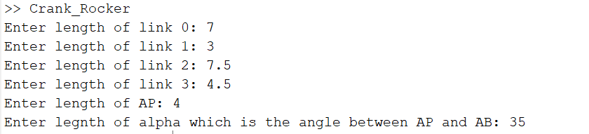

Before studying the 4-bar mechanism, we implemented in our code different inputs which has to be filled by the user so that he can design any 4-bar mechanism he wants to test. There are 2 additional variables than the 4 links which are the length of AP and the angle between AP and AB. These additional variables are used to draw the triangle above L2. (They can simply be set to 0 if we only want the 4 links)

Calculations:

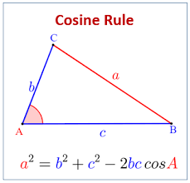Now since we studied a 4-bar mechanism using the vector loop approach (implemented in our assignment) we wanted to try another method which is why we opted to study the mechanism using the cosine rule.

for sides

for angles

We calculated different angles and lengths based on this rule, which represents this part of the code:

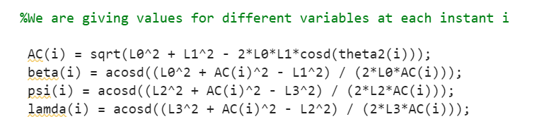

Now for the angle O3 and O4 as per the figure we just subtracted the correct angles to obtain them:

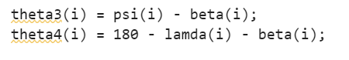

This equality won’t hold anymore when O2 is bigger than 180 degrees which led us to write this piece of code:

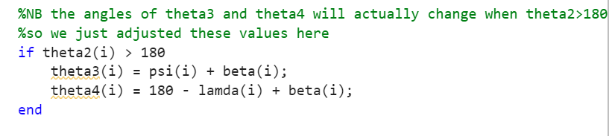

Now we wanted to include all this in a loop which updates the value of all these variables while O2 is changing from 0 to 720, which explains this loop:

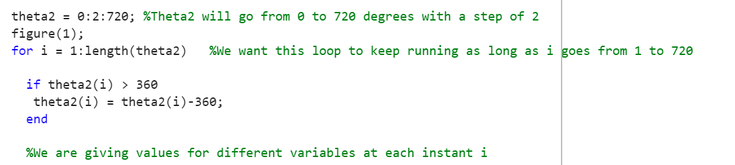

The next step is to define the joint positions:

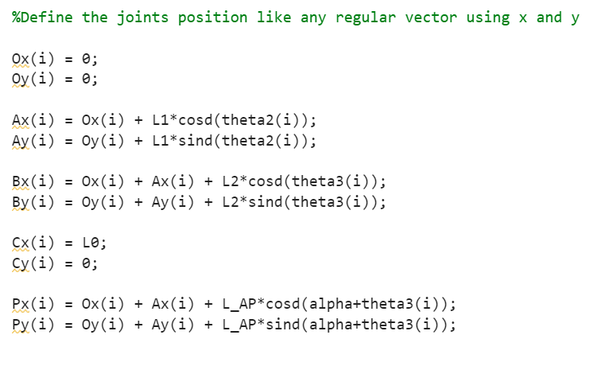

These are simply done by moving from origin Ox for x axis and Oy for y axis and adding the corresponding lengths with respect to these origins to arrive to a certain point.

For example the x component of A is L1 which is L_OA cos the angle between the x axis and L_OA which is O2. We do this for all the links which is shown in the figure above.

Now we want to get the angular velocity of link 3 and 4:

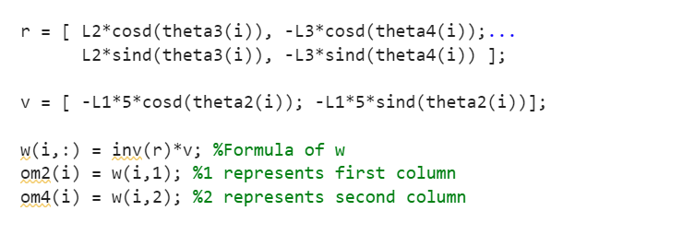

We first got Vx and Vy and R_L2 and R_L3 which led us to get w2 and w3.

In the first column of r we have the position of R_L2 in the x and y position. Similarly, in the second column of r we have the position R_ L3 in the x and y position.

For V we got Vx and Vy .To be able to do so we took our original w2 to be 5rad/s.

Vx = L*w2*cos(O2).

Om(2) is for link3.

Om(4) is for link4.

Additionally, we wanted to get the velocity at point P, V_Px and V_Py:

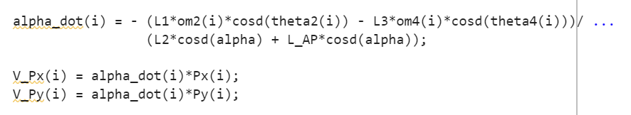

To get these values we first got alpha dot to be able to get V_Px and V_Py.

Finally we wanted to check which of the Grashof types our output was, this is done by this piece of code:

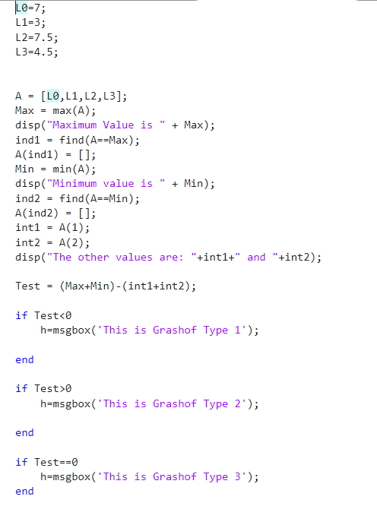

The remaining unexplained part of the code is for plotting the results which isn’t very important. We just coded some function and changed some parameters to obtain these outputs:

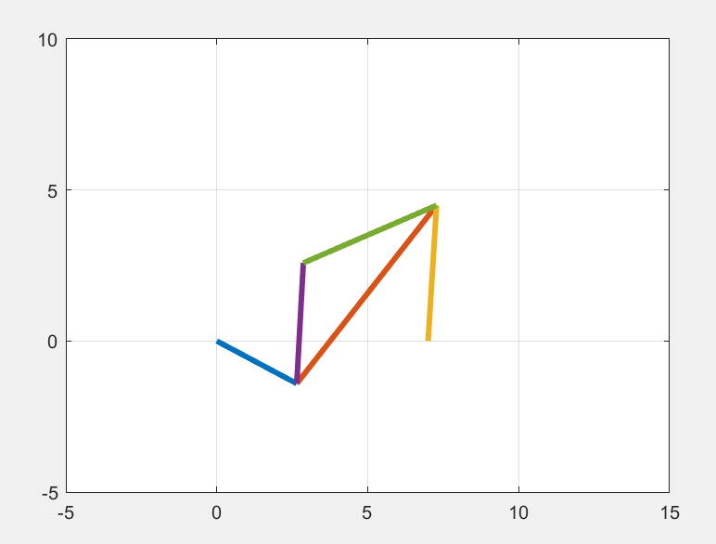

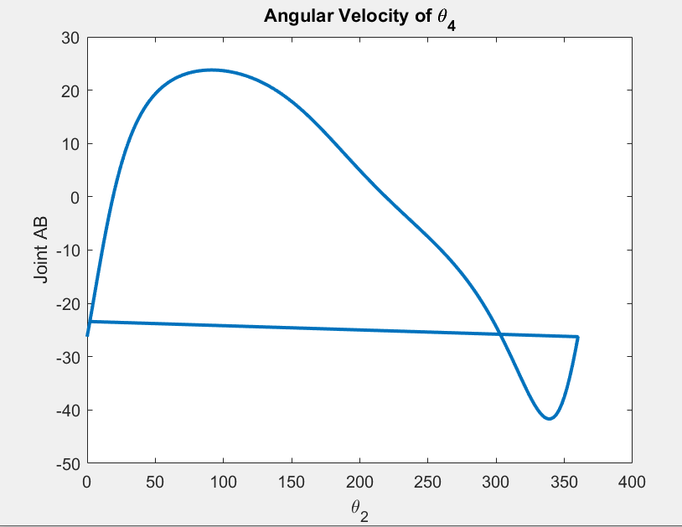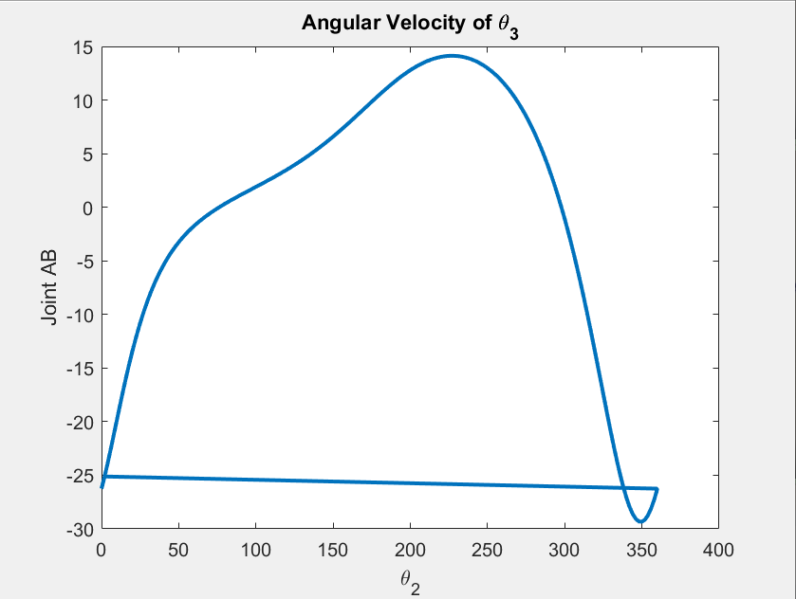

Proof of concept

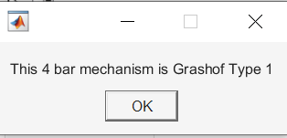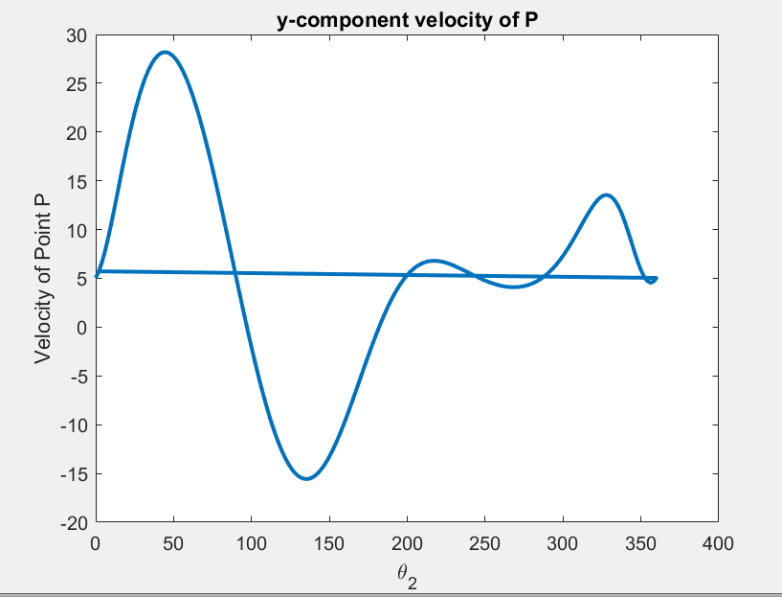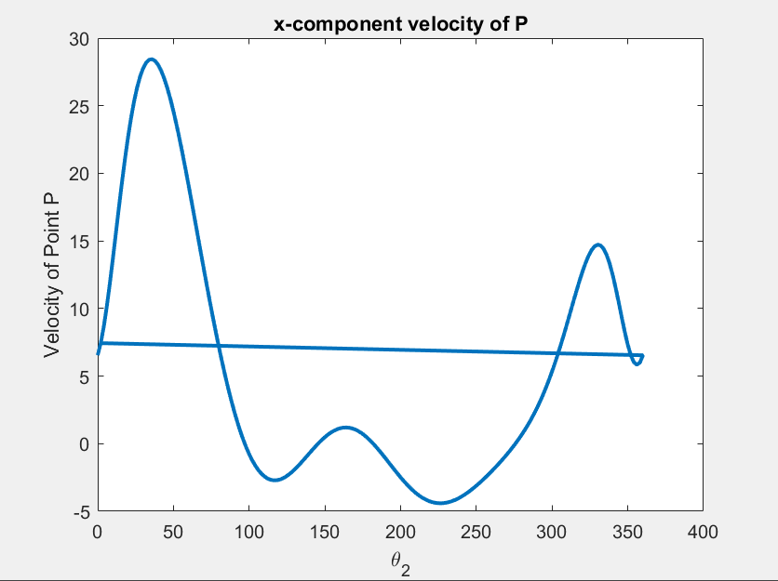

## Solidworks Design of gearbox and 4 bar mechanism:

All the simulation can be ran on solidworks or directly check them in PowerPoint

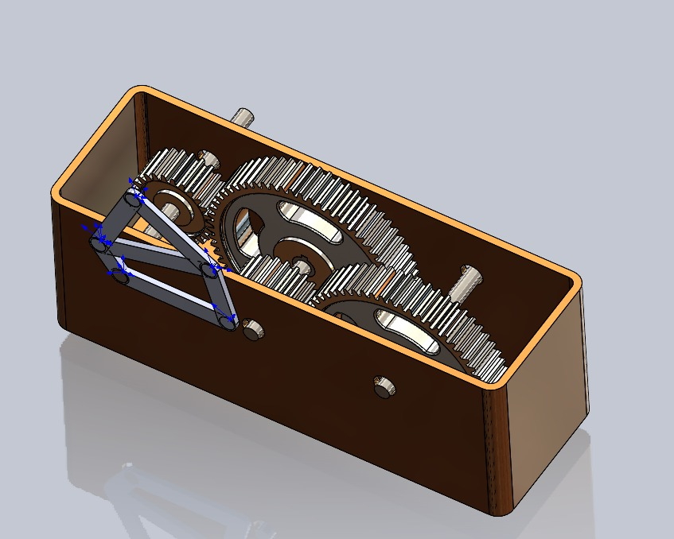

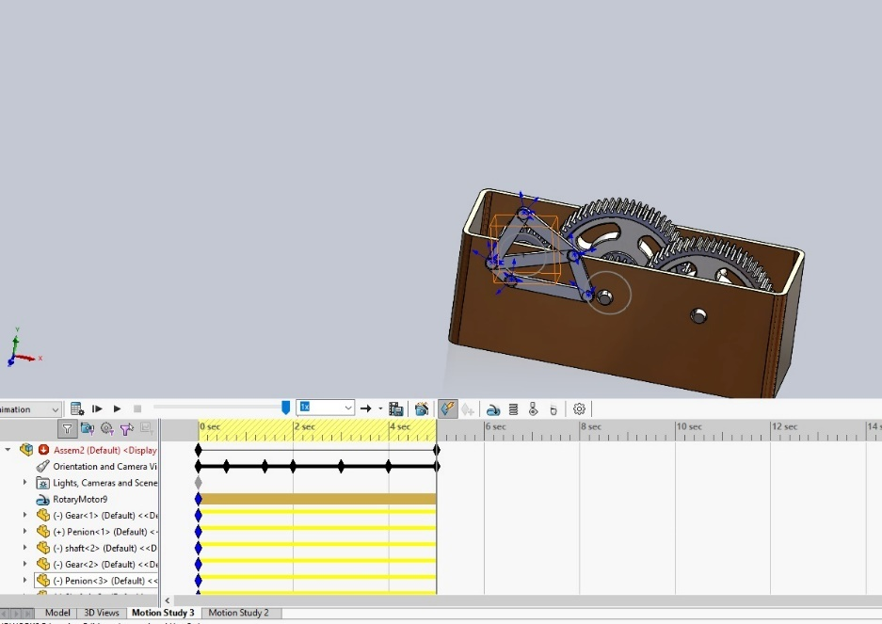

Gear 1: d1=4.2in, N1=25

Gear 2: d2=11in, N2=62

# Proof of concept:

Finally, we wanted to apply all this analysis and theoretical concepts to a real-life prototype. Our aim was to re enforce our knowledge and implement everything we learned in order to create a prototype that will show case the base concept of the project.

To be able to do this, we started by doing research to find different papers about the subject so we can have an idea of what is already done and learn from it. An example of this was a paper titled Electricity storage system: A Gravity Battery (which is in the reference)

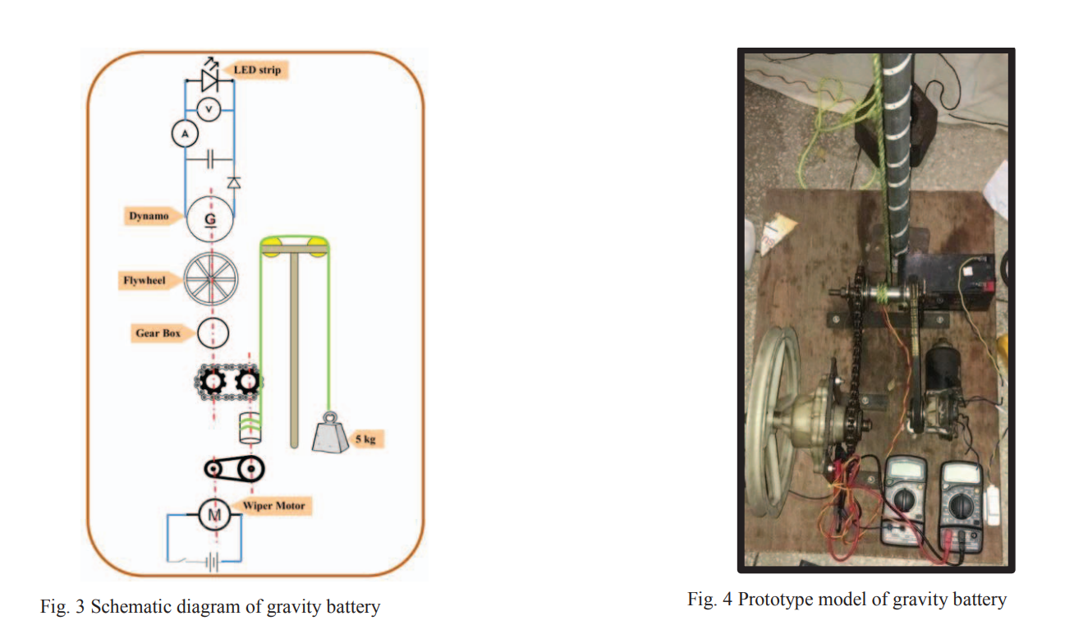

We loved the implementation but it was too complex and required a lot of time which we did not have. So we opted to a simpler solution while keeping in mind that the most important part of the implementation was showing the concept clearly.

The design we did is the same we had drawn on Solidworks and can be seen in the figure below:

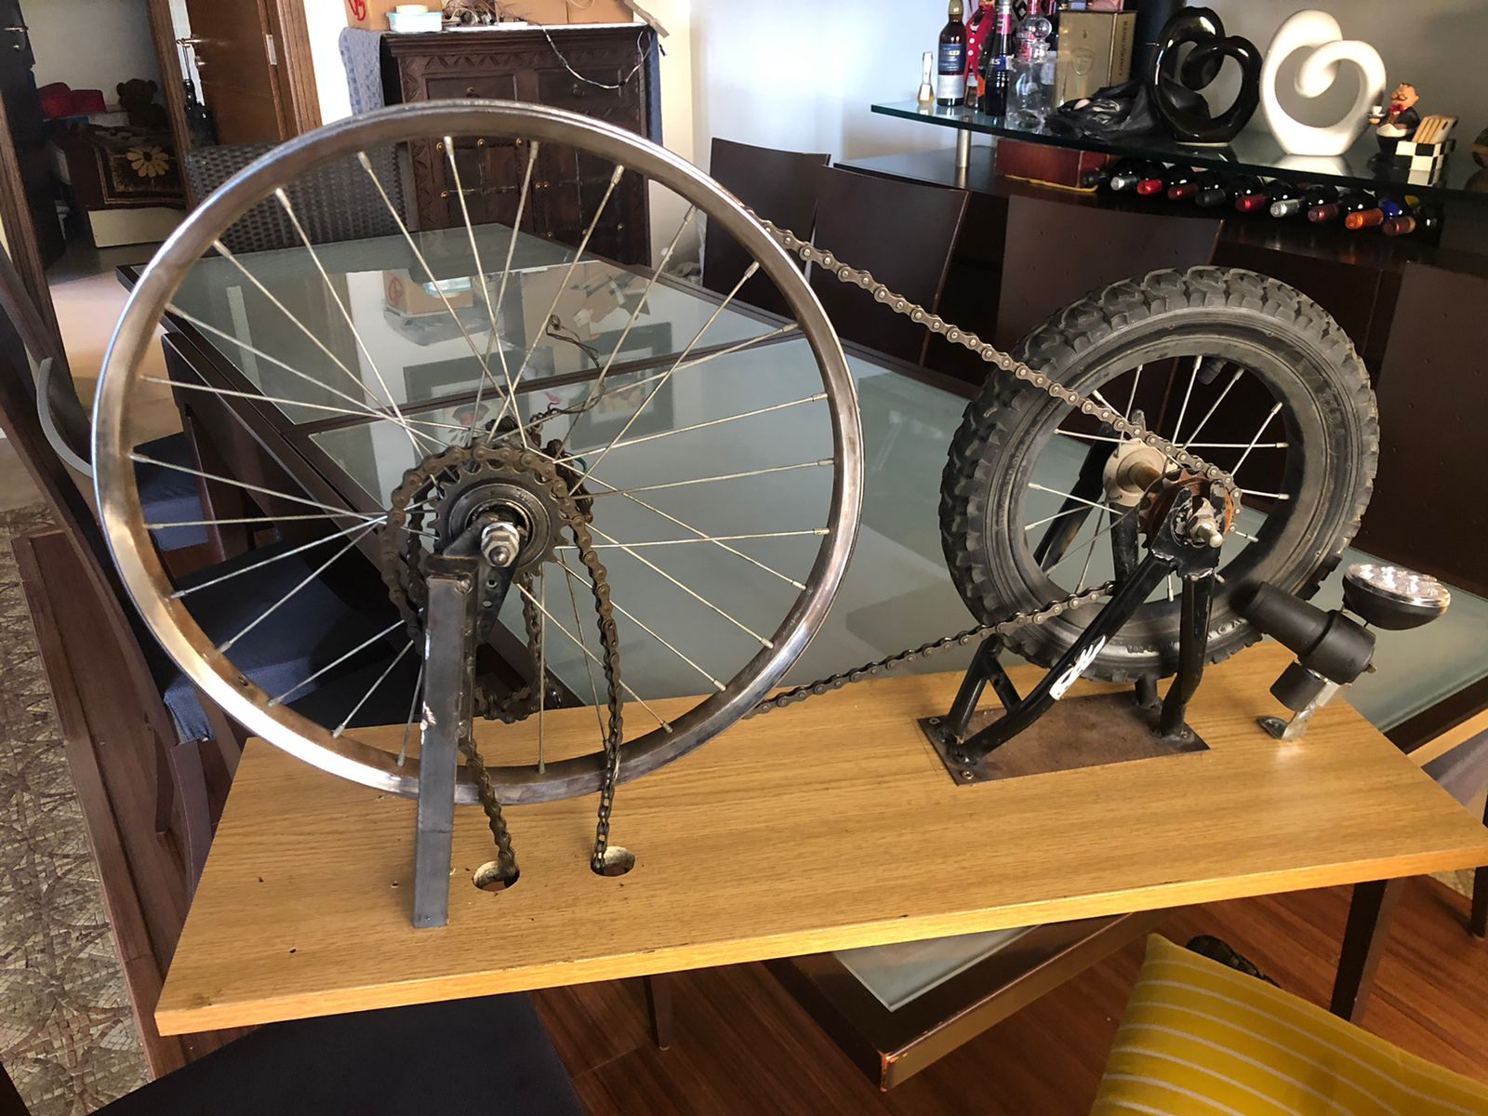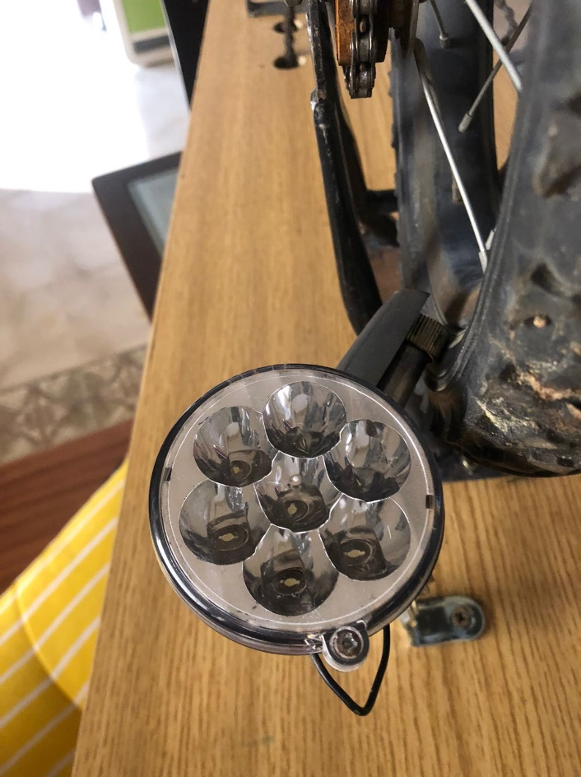

We did some calculations in order to ensure that our design will be working.

First of all we wanted to have the biggest gear ratio possible (while making sure the ratio doesn’t exceed 10).

We found the bicycle of Charbel’s brother which he doesn’t use anymore and thought that it would be a good opportunity to use the gear of the small wheel as our first gear. Unfortunately, being a small bike, the gear on the second wheel wasn’t big enough so we opted to another solution. We took a bigger wheel removed the tire and used the rim as a gear to have a larger big ratio ( as we couldn’t find a larger gear).

Gear 1 is the small gear and has a pitch diameter d1 = 2.75in

Gear 2 is the big gear and has a pitch diameter d2 = 11.25 in

It is important to note that the input and output gear will change if the battery is charging or discharging.

We will take a discharging case in this report as it is shown through our output. Our gear ratio is around 4. The bigger the gear ratio (implement a gear train for example) the better is our efficiency as the potential energy from the weight will result in a faster angular velocity w1 for our gear1 which will lead to the increase in the energy produced.

Then we wanted to buy a chain, but we first needed to figure out the length of that chain. To be able to get it we used this formula:

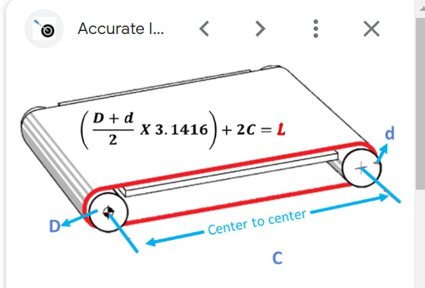

We used this formula as an estimation to the link of our chain as we couldn’t use the formula we have seen in class as we require the number of teeth of gear2 which are non existent. (and don’t have pitch)

Approximate maximum potential energy = m*g*hmax = 117.72 Joules.

Now the final part of this is to calculate the weight based on how fast the weight will go down and on the torque which will be transferred to gear1 having wout. We want wout to be big enough so that it can rotate the dynamo at a rate fast enough that the light will turn on.

We also know that the torque T is equal to the Force* the perpendicular distance.

Now we can get the tension of the mass applied on the chain. Represented by F

Replacing everything in the equation we will obtain that:

Now using the second law of Newton we can write that: (m alone will represent the mass of the weight going down).

This will result in the following relation:

A very important variable in our implementation is the friction of the dynamo on the wheel. Accounting to this variable we got by trial and error that the optimal weight for our case is 6kg. The theoretical part helped us a lot approximate but the high friction of the dynamo was an issue to get accurate results.

When the implementation was done, we were curious about the velocity fall of our weight so we did a measurement to calculate it.

Time to fall was 18 seconds and the vertical distance was 2m.

We wanted to note that this implementation is just a proof of concept and it needs improvements to be efficient. However, this project helped us really understand the material and made us discover and learn new topics. We can safely say that it was a beneficial experience and it developed our interest in the subject.